## **Agenda for Fourth Meeting**

|  |  |  |  |  |
| --- | --- | --- | --- | --- |
|  | | | | |
| **Skyward Federal**  **COPS Platform** | | **2/6/2020**  **1:00 PM to 2:00 PM**  [**https://meet.google.com/ecp-fedi-fbo**](https://meet.google.com/ecp-fedi-fbo)  **NCSU – EB2-2253** | | |
|  | | | | |
|  | | | | |
| Type of meeting: | Project Planning and Implementation | Note Taker:  Facilitator: | Jeen Shaji  Caleb Boswell | |
|  | | | | |
|  | | | | |
| Invitees: | Jonathan Balliet, Jeen Shaji, Daniel Mills, Caleb Boswell, Spencer Yoder, Erin Kotlyn, Danny Caudill, Ryan Carr | | | |
| Please read:  Meeting info: | Questions Below  <https://meet.google.com/ecp-fedi-fbo> | | | |
| **Agenda** | | | | |
|  | | | | |
| Agenda Overview | | All | | 5 min |
| Update | | All | | 10 min |
| Discuss 1st iteration | | All | | 10 min |
| Questions | | All | | 20 min |
| Action Items & Next Meeting | | All | | 5 min |
| **Additional Information** | | | | |
|  | | | | |
| Resource persons: | Dr. Jason King, Ms. Margaret Heil, Mr. Richard Kaufman, Erin Kotlyn, Danny Caudill, Ryan Carr | | | |

**Update**

* OPR/IPR
  + What we’ve done, what we have to do
* Language Decision
  + Python

**COPS Platform Questions**

**System Design**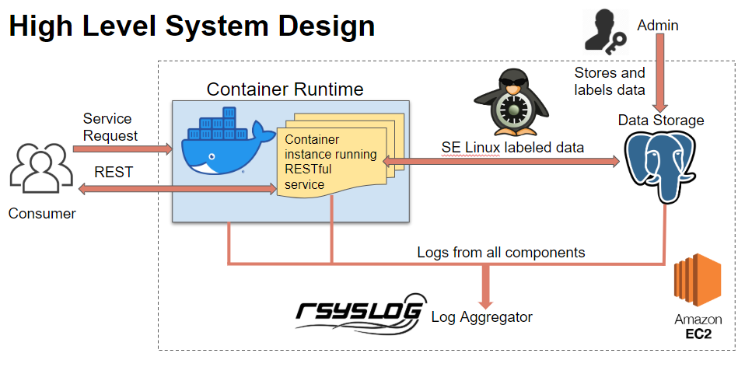

* Does this accurately convey what the high level design should look like? - Jonathan
* Where should the Log Aggregator be stored? Inside the same EC2 instance as the Container Runtime and Data Storage? - Jonathan
* Are there any log IDs that you have already decided on? - Caleb

**Data Storage**

* Based on what I read from the SE-Postgres documentation, we can only specify a security context for rows. Will we be maintaining tables with security contexts for other tables/columns? - Spencer
* Would it be okay for us to generate our own data for our dataset? (This would be both for development and presentation at the end of the semester) - Spencer
* Can you give us an example of what type data would be stored in the database? What it would look like and what file format/s should it support?- Jonathan

**Software**

* Are there any tutorials for the software you have designated, so we can familiarize ourselves with it before implementing it into the platform. - Caleb
* Do we need to know about any progress on your implementations before beginning our own? - Caleb

**Testing**

* Are there any particular points that you want tested in a particular way? - Caleb
* Do you already have some testing plans? - Caleb
* Are there any particular tools we should use or avoid using? - Spencer

**Logistics**

* Are we able to connect/are we responsible for the machines we can currently see on AWS? - Spencer

**Fourth Sponsor Meeting Minutes**

**Team**: Skyward Federal – MLS API Part 1 **Date**: February 6, 2020

**Facilitator**: Caleb Boswell **Recorder**: Jeen Shaji

**Attendance**:

* Spencer Yoder
* Jeen Shaji
* Jonathan Balliet
* Daniel Mills
* Caleb Boswell
* Dr. Jason King
* Ms. Margaret Heil
* Erin Kotlyn
* Danny Caudill
* Matthew Peters

**Minutes:**

**System Design**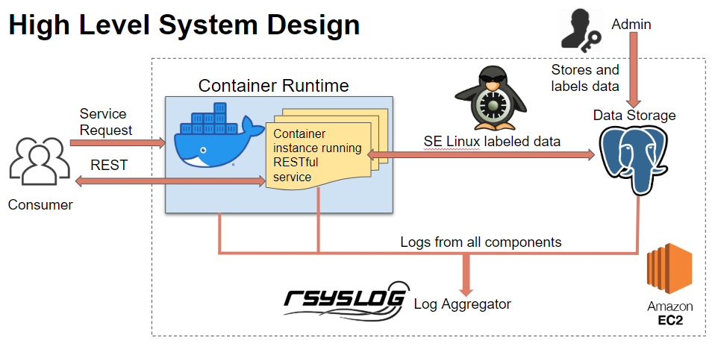

* Does this accurately convey what the high level design should look like? - Jonathan
* Looks good!
* Where should the Log Aggregator be stored? Inside the same EC2 instance as the Container Runtime and Data Storage? - Jonathan
* Stretch goal, aggregate logs from multiple places. Prefer it to be separate.
* Are there any log IDs that you have already decided on? - Caleb
* Skipped

**Data Storage**

* Based on what I read from the SE-Postgres documentation, we can only specify a security context for rows. Will we be maintaining tables with security contexts for other tables/columns? - Spencer
* Changed based on postgress rules discussed
* Would it be okay for us to generate our own data for our dataset? (This would be both for development and presentation at the end of the semester) - Spencer
* Sounds good to create own
* Can you give us an example of what type data would be stored in the database? What it would look like and what file format/s should it support?- Jonathan
* Admin can log in: update/ add date? Example of data
* Idea: latitude and longitude, highest population density, statistical data

**Software**

* Are there any tutorials for the software you have designated, so we can familiarize ourselves with it before implementing it into the platform. - Caleb
* In pdfs shared on slack platform
* Do we need to know about any progress on your implementations before beginning our own? - Caleb

**Testing**

* Are there any particular points that you want tested in a particular way? - Caleb
* Do you already have some testing plans? - Caleb
* Are there any particular tools we should use or avoid using? - Spencer
* Library called unittest
* Prove certain user tried to access - use unittes as a wrapper for testing the web api

**Logistics**

* Are we able to connect/are we responsible for the machines we can currently see on AWS? - Spencer
* **Turn it off!** All that you have access to it
* Gitlab, keycloak, jenkins, bastian
* Question: how our progress impacts yours?
  + As decoupled as possible.
* How useful is frontend?
  + If we get one, we will use it.
  + Make sure data doesn’t get altered.

|  |  |  |
| --- | --- | --- |
| **Action Item** | **Person Responsible** | **Due Date** |
|  |  |  |
|  |  |  |
|  |  |  |
|  |  |  |
|  |  |  |
|  |  |  |
|  |  |  |

**Meeting Evaluation:**

* **Positive -**
* **Negative -**

**Next Meeting:**